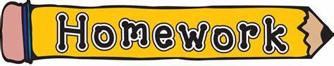

Week of Jan 17th to 21st, 2022
La Classe de Mme Bouchard – Division 13
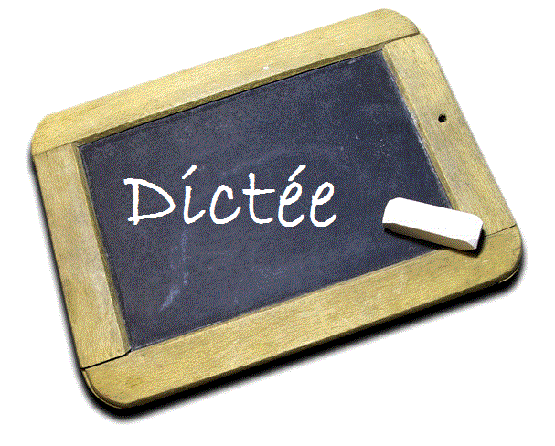

^{Dictée 10 – Le son “ch”}
Every day, please have your child copy the dictée words so that they learn how to write them by heart.
- une chose (a thing)
- un chat (a cat)
- un chien (a dog)
- chaque (each)
- c’est chouette (it’s cool)
- une chanson (a song)
- chanter (to sing)
- une ruche (a beehive)
- chercher (to look for)
- une chemise (a shirt)
Mot boni : du chocolat (some chocolate)
Practice, Practice, Practice!
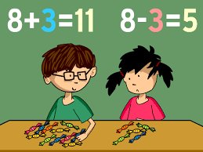

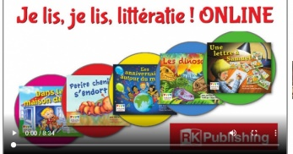 La Lecture
Every day of the week, please have your child take at least 10 to 15 minutes to read a French levelled book on the Je Lis Je Lis website. In order to become fluent readers and gain confidence in their reading skills, your child must practice reading in French as often as possible. If homework is a struggle, please put priority on reading, before Math or Dictée.
Please, go to the website: https://jelis.rkpublishing.com/student/
Use the Username and the Password that was provided to your child at the beginning of the duo-tang (Purple Homework Sheet.)

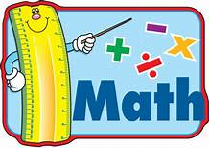
Additions
In grade 2, your child is expected to know their basic facts to

to a sum of 20. During the next few weeks, your child will be asked to complete a Math sheet to practice those facts.
For this week, please have your child practice the +5 additions on the sheet found in their homework duo-tang.

Please, have your child hand-in their homework duo-tang on Friday morning, while making sure that all of their homework is completed!

Have a wonderful week!

Mme Bouchard
Grade 2 Teacher – Division 13
École John Stubbs Memorial

